GTAS/PDIP

Software Design Document

Revision History
Date | Version | Description | Author
03-May-02 | 1.0 | Initial draft | Ang Meng Hua

Table of Contents
1. Introduction 4
1.1 Purpose 4
1.2 Scope 4
1.3 References 4
1.3.1 Book Reference 4
1.3.2 Online Reference 4
2. Three-tier Architecture Overview 4
2.1 Presentation Tier Technical Overview 5
2.1.1 ActionSerlvet 6
2.1.2 RequestProcessor 6
2.1.3 Action 6
2.1.4 EntityManager 6
2.1.5 WebClientController 6
2.2 Business Tier Technical Overview 6
2.2.1 EJBClientController 7
2.2.2 StateMachine 7
2.2.3 EventAction 7
2.2.4 ServiceFacade 7
2.3 Integration Tier Technical Overview 7
2.3.1 EntityHandler 7
2.3.2 EntityDAO 8
2.4 Inter-Tier Data Transfer 8
3. Application Services Design Model 8
3.1 User Management 8
3.2 Access Control 8
3.3 Partner Management 8
4. Base Services Design Model 9
4.1 XML Service 9
4.2 Security Service 9
4.3 Transport Service 9
4.4 Packaging Service 9
5. Framework Services Design Model 9
5.1 Persistence Framework 9
5.2 Exception Framework 9
5.3 Logging Service 10
5.4 Lookup Service 10
5.5 Configuration Service 10
5.6 File Access Service 10

Introduction

Purpose
The software design document primary purspose is to provide a software design repository for capturing all designs of the software system in its entirety. It should also serve as a good reference for various people interested in the design model, such as the software architect, designers, testers, reviewers, and managers.

Scope
This document provides a general overview of the architecture of the software system and describe the design model of the various sub-systems and components in the software system.

References

Book Reference
- Deepak Alur, John Crupi, Dan Malks. Core J2EE Patterns Best Practices and Design Strategies. Prentice-Hall
- Floyd Marinescu. EJB Design Patterns Advanced Patterns, Processes and Idioms. John Wiley & Sons
- Ed Roman, Scott Ambler, Tyler Jewell. Mastering Enterprise JavaBeans, 2nd Edition. John Wiley & Sons

Online Reference
- Serverside.com. A news source and developer commmuity centered around J2EE and middleware issues. http://www.theserverside.com
- EJB Interest Group: http://archives.java.sun.com/archives/ejb-interest.html
- J2EE Interest Group : http://archives.java.sun.com/archives/j2ee-interest.html

Three-tier Architecture Overview

Many applications, and J2EE application especially, can be described in terms of their tiers. The application’s functionality is separated across these tiers, or functional layers, to provide separation of responsibility, reuse, improved scalability, and many other benefits.

Enhanced with a design patterns centric architecture, the architecture implementation ensures higher performance and highest level of reuse for each of the different facets of the framework. Figure 1 shows the design pattern oriented view of the three-tier architecture implemented by the application.

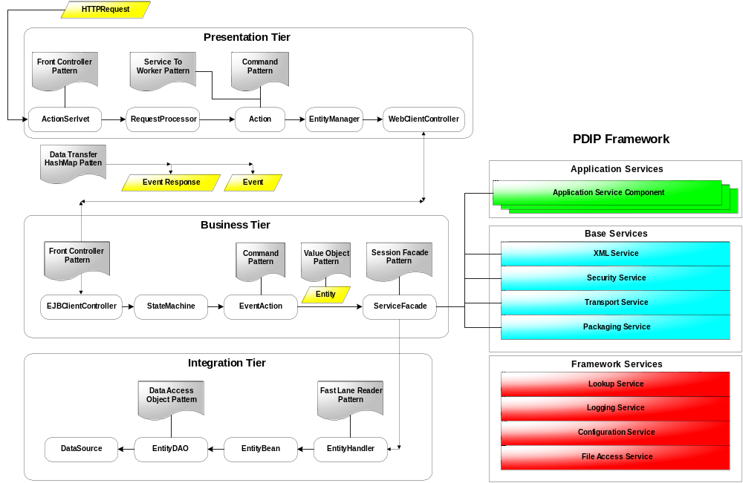
Figure 1: Design patterns oriented three-tier architecture

As seen in the diagram, the application uses the application service components in the PDIP framework layer extensively for their well encapsulated business logic via the ServiceFacade interface. The application service components are meant to be reusable across all GridNode products. The base service components and the framework service components provide the application infrastructure to support the business services at the upper layers. For an overview of the PDIP framework, please refer to tbd

The sections that follow gives a high level technical overview of each tier by describing the functionalities implemented by the components as well as the design patterns they supported. It presents them in the format similar to the CRC*.

*CRC : a technique in object-oriented development, originally proposed by Ward Cunningham and Kent Beck, to help define what objects should do in the system (their responsibilities), and identify other objects (the collaborators) that are involved in fulfilling these responsibilities.

Presentation Tier Technical Overview

This tier encapsulates all presentation logic required to service the clients that access the system. The presentation tier intercepts the client request, forwards the request to the business tier, constructs the responses, and delivers the responses to the client.

The application leverages on the Jarkata Structs* framework for its comprehensive low-level infrastructure functionality like request dispatching and field-level validation and, more importantly, its prefect implementation of the MVC Model 2 architecture.

*Structs is an open source framework for building Web applications that integrates with standard technologies like Java Servlets, JavaBeans, and JavaServer Pages (JSP). It fits well in the presentation tier.

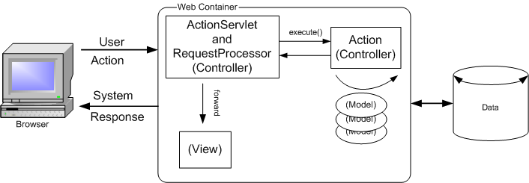

Figure 2 : The ActionSerlvet, RequestProcessor and Action controller components in Structs

ActionSerlvet
Responsibility : The ActionSerlvet is a component provided by the Structs framework. It implements the front controller pattern by providing a centralized access point to intercept all user's requests, packages and routes the HTTP traffic to the appropriate handler in the framework, and manages the choice of an appropriate view.

Collaboration : It delegates the handling of the request to the RequestProcessor.

RequestProcessor
Responsibility : The RequestProcessor is a component provided by the Structs framework. It handles the request by routing it to the appropriate helper class. This helper class knows how to execute the business operation that is associated with the requested action

Collaboration : It delegates the handling of the request to the Action helper class. it determines the appropriate helper class to handle the request by inspecting the request information and utilizing a set of URL-Action mappings defined in a configuration file.

Action
Responsibility : An extension of the controller component in the Structs framework. It acts as an adaptor between a user action and a business operation. It implements the Command pattern by extending the Structs base Action class to provide its own logic to handle application specific actions.

Collaboration : It forwards the request to the appropriate EntityManager.

EntityManager
Responsibility : The EntityManager handles all requests pertaining to the management of the entity, eg. create, update, delete, search, ... etc. It maps the HTTP request parameter to an Event object

Collaboration : It forwards the event to the WebClientController.

WebClientController
Responsibility : A component that acts as a bridge to the business tier. It forwards the event received from the EntityManager to the business tier. A single instance of this exists for every client’s session. It caches a reference to the EJBClientController to avoid expensive JNDI lookup.

Collaboration : It forwards the event to the EJBClientController in the business tier

Business Tier Technical Overview

This tier provides the business services required by the application clients. The business services providers are typically enterprise beans components and other helper classes that implement the business logic processing.

EJBClientController
Responsibility : The EJBClientController has a one to one relationship with the WebClientController in the presentation tier. It implements the front controller pattern by intercepting all events flowing from the presentation tier and routing the event to the StateMachine for further processing.

Collaboration : It forwards the event to the StateMachine.

StateMachine
Responsibility : The StateMachine instantiates the appropriate EventAction object capable of handling the event. It determines the appropriate EventAction object using the event name and event action mappings. It caches the instantiated EventAction object for reuse for subsequent events. In addition, it provides an attribute maps for storing state information.

Collaboration : It delegates the event handling to the EventAction object.

EventAction
Responsibility : The EventAction implements the Command pattern. It encapsulates the business logic required to handle the event. It does so by delegating to the appropriate business components in the business tier for processing. The business components are typically provided by the application service component. It also handles the translation of the event data to business value objects required by the business components as well as mapping the result to the event response data to be sent across the presentation tier.

Collaboration : It is coupled to the application service component via the ServiceFacade interface.

ServiceFacade
Responsibility : It implements the Session Façade pattern by providing a facade to the services of the underlying application business components or base service components. Application business components can be a partner management component, user management component, access control component etc. It is typically implemented as a stateless session bean

Collaboration : It delegates all entity management related services, like create, update, delete, find to the EntityHandler

Integration Tier Technical Overview

This tier is responsible for communicating with external resources and systems such as data stores and legacy applications. Components in this tier encapsulate the logic required to access external resources.

EntityHandler
Responsibility : The EntityHandler front all access to the EntityBean. It provides a fast-lane reader service for all read-only finder methods using DAO direct. A fast-lane reader accelerates read-only data access by avoiding the overhead associated when using the enterprise beans. It caches a reference to the EntityBean local home interface.

Collaboration : It delegates the services to manage the entities to EntityBean.

EntityDAO
Responsibility : The EntityDAO decouples the business logic from data access logic by encapsulating all access to data store.

Collaboration : It uses the DataSource to gain access to the Connection objects from the connection pools. A DataSource is a factory for Connection objects.

Inter-Tier Data Transfer

This section addresses the fundamental question of how to get data from the front end to the business logic layer and vice versa. As shown in Figure 1, the presentation tier and the business tier communicates by means of wrapping the event data and event response data in the Event object and the EventResponse object respectively. The Event and EventResponse objects are carried across the tiers via the WebClientController and the EJBClientController.

Both Event and EventResponse objects implements the data transfer HashMap pattern to decouple the presentation tier from the business tier. The event data and event response data are represented as key-value pairs in the HashMap. In this way, the presentation tier does not need to deal with the domain business data objects in the business tier directly and is therefore shield from changes made to the business data objects. All that is required is a simple contract for attribute keys defined in a shared data object interface that only exposes those fields in the business data objects needed by the presentation tier.

Figure shows the class hierarchy of the Event and EventResponse objects.

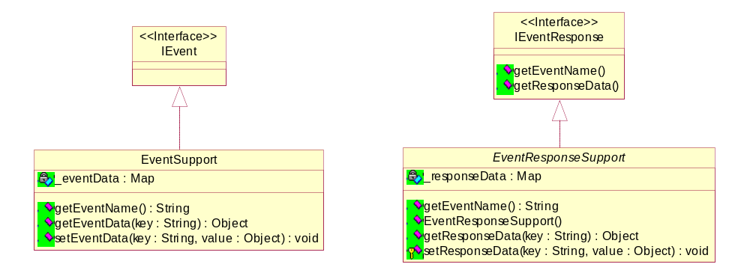

The application may implement specific Event and EventResponse objects by extending from the EventSupport and EventResponseSupport base classes, eg. a CreateUserAccountEvent, DeleteUserAccountEvent, etc.

Application Services Design Model

User Management

Access Control

Partner Management

Base Services Design Model

XML Service

Security Service

Transport Service

Packaging Service

Framework Services Design Model

Persistence Framework

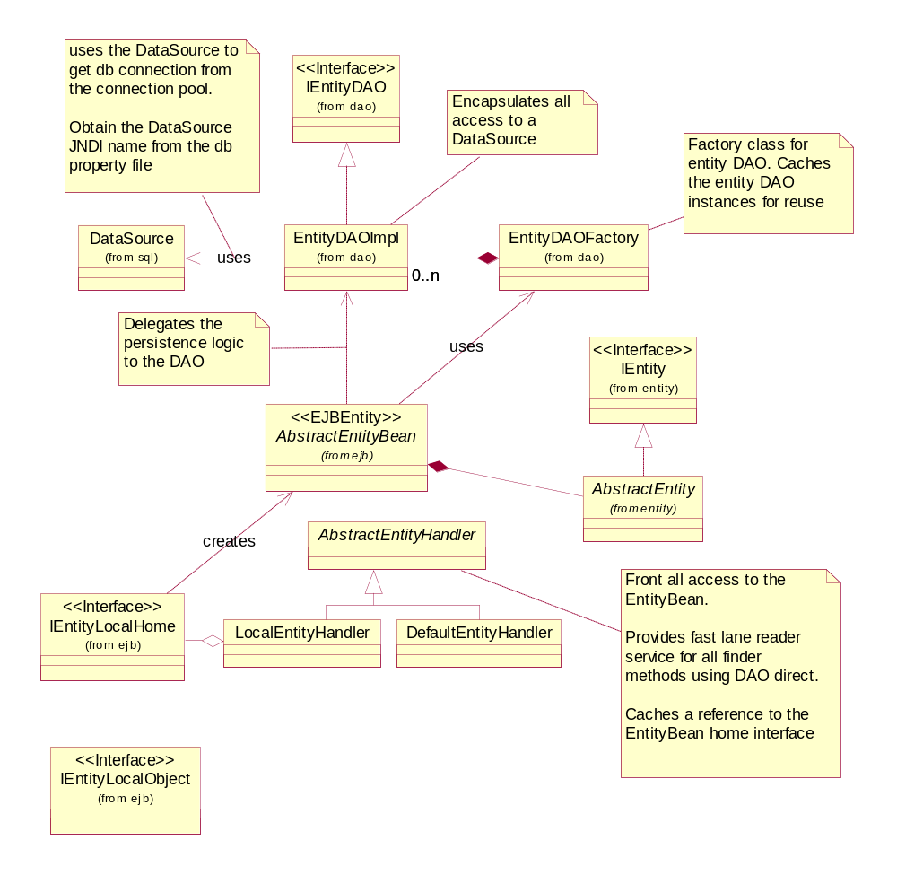

Exception Framework

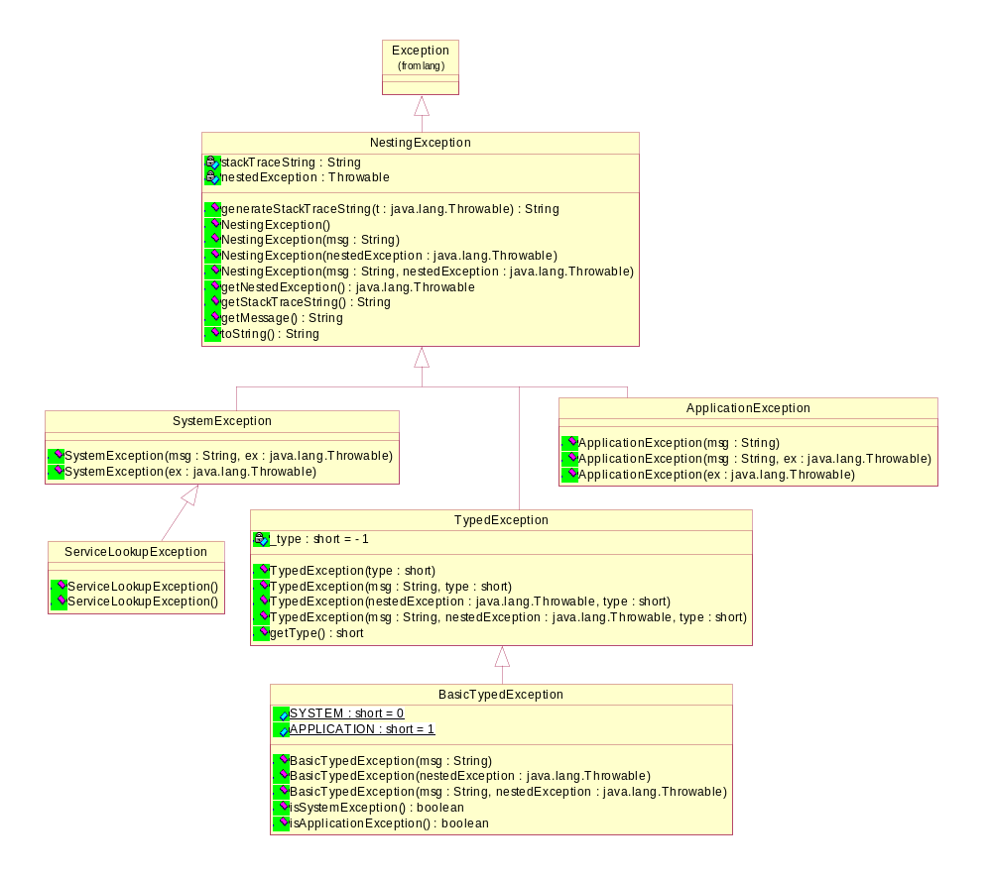

Logging Service

Lookup Service

Configuration Service

File Access Service

